***Mini Project Report***

***on***

**Study and Implementation of Five Factor Model**



**Submitted By**

**Md. Monirul Islam (Reg. No.-202000237)**

**Phirat Passi (Reg. No.-202000553)**

**Sourav Dutta (Reg. No.-202000402)**

**Group Id – C20**

*In partial fulfillment of requirements for the award of degree in*

*Bachelor of Technology in Computer Science and Engineering*

*(2023)*

Under the Project Guidance of

**Mrs. Minakshi Roy**

**Assistant Professor (SG)**

**Department of Computer Science & Engineering**

**Sikkim Manipal Institute of Technology, Majitar**

**DEPARTMENT OF COMPUTER SCIENCE AND ENGINEERING**

**SIKKIM MANIPAL INSTITUTE OF TECHNOLOGY**

(A constituent college of Sikkim Manipal University)

MAJITAR, RANGPO, EAST SIKKIM – 737136

**PROJECT COMPLETION CERTIFICATE**

This is to certify that the below mentioned students of Sikkim Manipal Institute of Technology have worked under my supervision and guidance from **9th January 2023 to 29th** **April 2023** and successfully completed the Mini project entitled **“Study and Implementation of Five Factor Model”** in partial fulfillment of the requirements for the award of Bachelor of Technology in Computer Science and Engineering.

|  |  |  |
| --- | --- | --- |
| University Registration No | Name of Student | Course |
| **202000237** | **Md. Monirul Islam** | **B.Tech (CSE)** |
| **202000553** | **Phirat Passi** | **B.Tech (CSE)** |
| **202000402** | **Sourav Dutta** | **B.Tech(CSE)** |

**Mrs. Minakshi Roy**

Assistant Professor (SG)

Department of Computer Science and Engineering

Sikkim Manipal institute of Technology

Majhitar, Sikkim – 737136

**PROJECT REVIEW CERTIFICATE**

This is to certify that the work recorded in this project report entitled “**Study and Implementation of Five Factor Model**” has been jointly carried out by **Md. Monirul Islam (Reg. 202000237), Phirat Passi (Reg. 202000553) and Sourav Dutta (Reg. 202000402)** of Computer Science & Engineering Department of Sikkim Manipal Institute of Technology in partial fulfillment of the requirements for the award of Bachelor of Technology in Computer Science and Engineering. This report has been duly reviewed by the undersigned and recommended for final submission for Mini Project Viva Examination.

**Mrs. Minakshi Roy**

Assistant Professor (SG)

Department of Computer Science and Engineering

Sikkim Manipal Institute of Technology

Majhitar, Sikkim – 737136

**CERTIFICATE OF ACCEPTANCE**

This is to certify that the below mentioned students of Computer Science & Engineering Department of Sikkim Manipal Institute of Technology (SMIT) have worked under the supervision of **Mrs. Minakshi Roy**, Assistant Professor (SG), Department of Computer Science and Engineering from **9th January 2023 to 29th April 2023** on the project entitled **“Study and Implementation of Five Factor Model”.**

The project is hereby accepted by the Department of Computer Science & Engineering, SMIT in partial fulfillment of the requirements for the award of Bachelor of Technology in Computer Science and Engineering.

|  |  |  |
| --- | --- | --- |
| University Registration No | Name of Student | Project Venue |
| **202000237**  **202000553**  **202000402** | **Md. Monirul Islam**  **Phirat Passi**  **Sourav Dutta** | **SMIT** |



**Dr. Udit Kumar Chakraborty**

Professor & Head of the Department

Computer Science & Engineering Department

Sikkim Manipal Institute of Technology

Majhitar, Sikkim – 737136

**DECLARATION**

We, the undersigned, hereby declare that the work recorded in this project report entitled “**Study and Implementation of Five Factor Model**” in partial fulfillment for the requirements of award of B.Tech (CSE) from Sikkim Manipal Institute of Technology (A constituent college of Sikkim Manipal University) is a faithful and bonafide project work carried out at “**SIKKIM MANIPAL INSTITUTE OF TECHNOLOGY**” under the supervision and guidance of **Mrs. Minakshi Roy,** Assistant Professor (SG), Department of Computer Science and Engineering.

The results of this investigation reported in this project have so far not been reported for any other Degree or any other Technical forum.

The assistance and help received during the course of the investigation have been duly acknowledged.

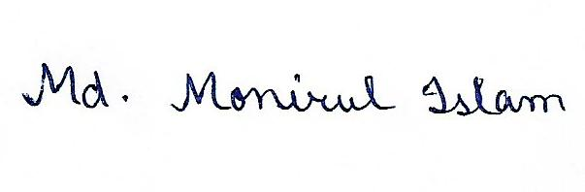

**Md. Monirul Islam (Reg. No.-202000237)**



**Phirat Passi (Reg. No.-202000553)**



**Sourav Dutta (Reg. No.-202000402)**

**ACKNOWLEDGMENT**

We take this opportunity to acknowledge indebtedness and a deep sense of gratitude to our guide **Mrs. Minakshi Roy** for his/her valuable guidance and supervision throughout the course which shaped the present work as it shows.

We pay our deep sense of gratitude to **Prof. (Dr.) Udit Kumar Chakraborty, HOD, Computer Science & Engineering Department, Sikkim Manipal Institute of Technology** for giving us the opportunity to work on this project and providing all support required.

We are obliged to our project coordinators **Dr. Sandeep Gurung** and **Mr. Biraj Upadhyaya** for elevating, inspiration and supervising in completion of our project.

We would also like to thank any other staff of **Computer Science & Engineering Department, Sikkim Manipal Institute of Technology** for giving us continuous support and guidance that has helped us in completion of our project.

**Md. Monirul Islam (Reg. No.-202000237)**

**Phirat Passi (Reg. No.-202000553)**

**Sourav Dutta (Reg. No.-202000402)**

**DOCUMENT CONTROL SHEET**

|  |  |  |
| --- | --- | --- |
| 1 | Report No | CSE/Mini Project/Internal/B.Tech/Section/Group ID(C20)/2023 |
| 2 | Title of the Report | **Study and Implementation of Five Factor Model** |
| 3 | Type of Report | Technical |
| 4 | Author | Md. Monirul Islam (Reg. No.-202000237)  Phirat Passi (Reg. No.-202000553)  Sourav Dutta (Reg. No.-202000402) |
| 5 | Organizing Unit | Sikkim Manipal Institute of Technology |
| 6 | Language of the Document | English |
| 7 | Abstract | The report provides an overview of Five Factor Model (FFM), a widely accepted framework for understanding human personality, including its theory, assessment methods and research on the impact of personality traits on life outcomes. Implications for organizations and future research are also addressed. |
| 8 | Security Classification | General |
| 9 | Distribution Statement | General |

**TABLE OF CONTENTS**

|  |  |  |  |
| --- | --- | --- | --- |
| **Chapter** |  | **Title** | **Page No.** |
|  |  | Abstract |  |
| 1 |  | Introduction | 1 - 3 |
| 2 |  | Literature Survey | 4 - 5 |
| 3 |  | Problem Definition | 6 |
| 4 |  | Solution Strategy | 7 - 8 |
| 5 |  | Design | 9 - 11 |
|  | 5.1 | System Architecture for the Career Prediction Application | 9 |
|  | 5.2 | Flowchart of BFI-10 Scoring | 10 |
|  | 5.3 | Flowchart of BFI-10 to MBTI Mapping | 11 |
| 6 |  | Implementation details | 12 - 19 |
|  | 6.1 | Pseudo Code for BFI-10 Scoring | 12 |
|  | 6.2 | Pseudo Code for BFI-10 to MBTI Mapping | 13 |
|  | 6.3 | BFI Scoring | 14 -16 |
|  | 6.4 | BFI-10 to MBTI Mapping | 16 - 19 |
| 7 |  | Results and discussion | 20 - 21 |
| 8 |  | Conclusion | 22 |
| 9 |  | Limitations and Future Scope of the project | 23 -24 |
|  | 9.1 | Limitations of the Project | 23 |
|  | 9.2 | Future Scope of the Project | 24 |
| 10 |  | Gantt Chart | 25 |
| 11 |  | References | 26 |
| 12 |  | Plagiarism Report | 27 |

**LIST OF FIGURES**

|  |  |  |
| --- | --- | --- |
| **Figure No.** | **Figure Name** | **Page No.** |
| 1.1 | Five Factor Model (FFM) | 2 |
| 1.2 | Myers-Briggs Type Indicator (MBTI) | 3 |
| 5.1 | System Architecture for the Career Prediction Application | 9 |
| 5.2 | Flowchart of BFI-10 Scoring | 10 |
| 5.3 | Flowchart of BFI-10 to MBTI Mapping | 11 |
| 7.1 | Home Page | 20 |
| 7.2 | Results Page | 21 |
| 7.3 | About Model Page | 21 |
| 10.1 | Gantt Chart | 25 |

**LIST OF TABLES**

|  |  |  |
| --- | --- | --- |
| **Table No.** | **Title Name** | **Page no.** |
| 6.1 | Table for BFI Scoring | 15 |
| 6.2 | Table for Personality Trait Scores | 16 |
| 6.3 | Table for BFI to MBTI mapping | 18 |

**ABSTRACT**

The aim of this project is to predict an individual's career path by utilizing multiple models that determine personality, which include the Myers-Briggs Type Indicator (MBTI), Five Factor Model (FFM), and Big Five Inventory (BFI-10). The MBTI is a popular personality framework that places individuals into one of 16 personality types based on their preferences for four dichotomies: extraversion/introversion, sensing/intuition, thinking/feeling, and judging/perceiving. The FFM, also known as the Big Five personality traits, categorizes personality traits into five dimensions: openness, conscientiousness, extraversion, agreeableness, and neuroticism. The BFI-10 is a shorter version of the Big Five Inventory which uses 44 questions and measures each of the five personality dimensions with ten items.

This project's goal is to analyze an individual's personality traits as assessed by the MBTI, FFM, and BFI-10 and predict a career path that matches their personality traits. For example, an individual who scores high in extraversion, intuition, thinking, and judging on the MBTI may be well-suited for a career in engineering, while an individual who scores high in openness and agreeableness on the FFM may be well-suited for a career in social work. It's crucial to remember that while personality traits are one factor in determining career suggestions, other factors such as personal interests, values, and skills must also be taken into account. The primary objective of this project is to contribute to the existing data set for research on career prediction, which can help individuals make informed decisions about their future career paths.

**1. INTRODUCTION**

In the current competitive landscape, selecting a suitable career path can be a daunting task for students due to the vast array of available fields. To achieve their goals, students need to plan and organize their lives from an early stage. This involves evaluating their performance regularly, identifying their interests, tracking their progress, and ensuring they are on the right path to reach their objectives.

Predictive analytics is an advanced analytics branch that combines statistical modelling, data mining techniques, and machine learning to make predictions about future outcomes using historical data. One of the applications of predictive analytics is in assessing human behavioral traits through personality assessments. Some popular models, namely Five Factor and MBTI, are utilized to evaluate a person's qualitative attributes, which in turn aid in predicting their career trajectory.

**1.1 Five Factor Model (FFM):**

The Big Five personality traits are a widely accepted categorization of personality traits into five groups. These five groups are openness to experience, conscientiousness, extraversion, agreeableness, and neuroticism. Each factor consists of more specific primary traits, such as gregariousness and assertiveness for extraversion, and sensitivity and nervousness for neuroticism. The acronyms "OCEAN" or "CANOE" can be used to remember these factors. The Big Five personality traits provide a useful framework for understanding personality differences and predicting behavior in various contexts, including in the workplace and in social interactions.

The 5 traits are:

• Openness to experience (inventive/curious vs. consistent/cautious)

• Conscientiousness (efficient/organized vs. extravagant/careless)

• Extraversion (outgoing/energetic vs. solitary/reserved)

• Agreeableness (friendly/compassionate vs. critical/rational)

• Neuroticism (sensitive/nervous vs. resilient/confident)

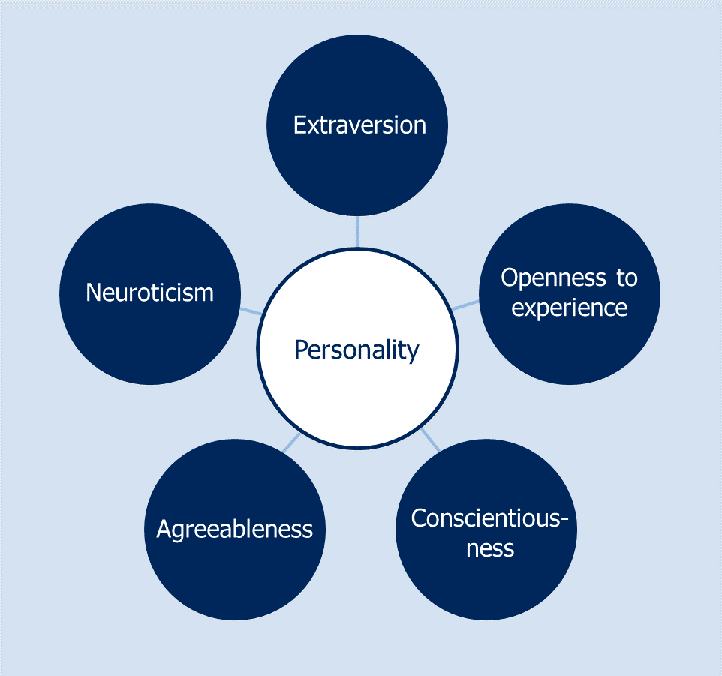

Figure 1.1: Five Factor Model (FFM)

**1.2 Myers-Briggs Type Indicator (MBTI)**

In personality typology, the Myers–Briggs Type Indicator (MBTI) is an introspective self-report questionnaire indicating differing psychological preferences in how people perceive the world and make decisions. Despite its popularity, it has been widely regarded as pseudoscience by the scientific community. The test attempts to assign a value to each of four categories: introversion or extraversion, sensing or intuition, thinking or feeling, and judging or perceiving.

The MBTI assesses personality traits based on 4 dichotomous pairs of preferences:

• Extraversion (E) – Introversion (I)

• Sensing (S) – Intuition (N)

• Thinking (T) – Feeling (F)

• Judging (J) – Perceiving (P)

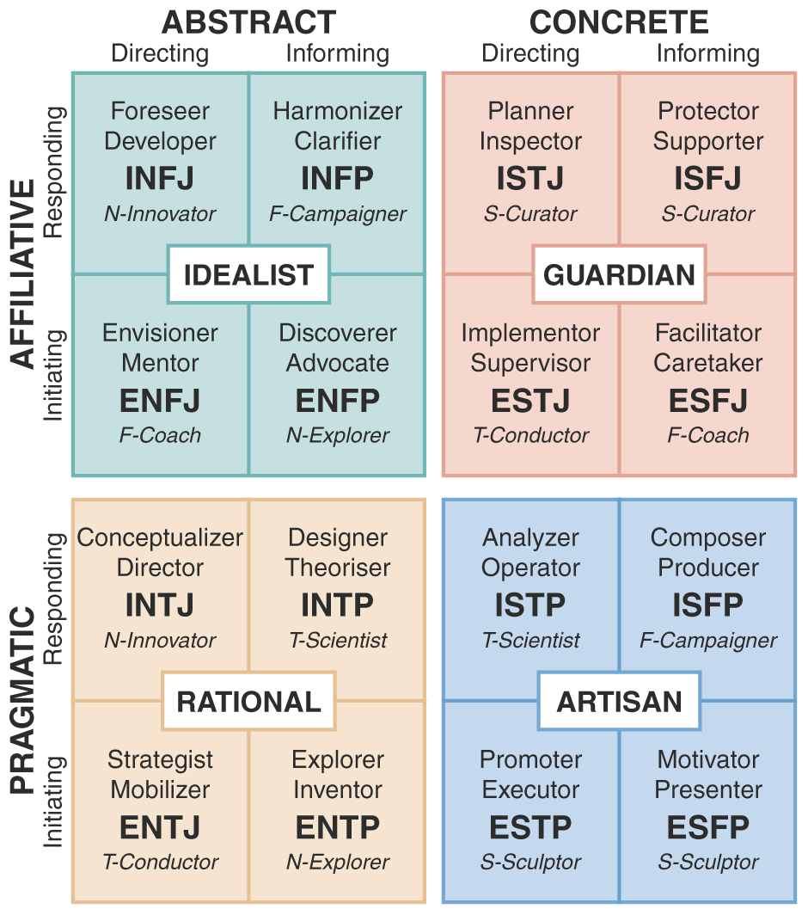

Figure 1.2: Myers-Briggs Type Indicator (MBTI)

1. **LITERATURE SURVEY**

|  |  |  |  |  |
| --- | --- | --- | --- | --- |
| **Sl. No.** | **Author** | **Paper and Publication Details** | **Findings** | **Relevance** |
| 1. | Rammstedt, B. & John, O.P | Measuring personality in one minute or less: A 10-item short version of the Big Five Inventory in English and German [2007] | Big Five Inventory (BFI-10), personality measurement, psychometric properties, questionnaire development. | It will help us to measure the personality of a student into 5 criteria based on the standardized questionnaire |
| 2. | Pratiyush Guleria, Manu Sood | Explainable AI and machine learning: performance evaluation and explainability of classifiers on educational data mining inspired career counselling [2022] | In this paper, the following methods have been utilized: Decision Tree, Support Vector Machine and Logistic Regression | It will guide students to decide appropriate career according to their capabilities |
| 3. | Prof. Priyanka Shahane, Prutha Rinke, Taniksha Datar, Soham Badjate | Student’s Career Interest Prediction using Machine Learning [2022] | In this paper, the following methods have been utilized: Decision Tree, Support Vector Machine, One Hot Encoding, XG Boost | It will assist them with self-improvement and motivation to make the right choice |
| 4. | Chelsea Song, Hyun Joo Shin, Chen Tang, Alexis Hanna, et. al. | Investigating machine learning’s capacity to enhance the prediction of career choices [2022] | In this paper, the following methods have been utilized: RAISEC(Holland), Kth Nearest Neighbour, Elastic Net, Random Forest | It will enhance the accuracy of interest inventory-based career choice prediction |
| 5. | Abhishek S Rao, Bola Sunil Kamath, Ramya R, Shreya Chowdhury, et. al. | Neural network in developing a personality prediction model for career guidance: A Boon for Career [2021] | In this paper, the following methods have been utilized: Artificial Neural Network, K-Folds cross-validation | It will try to learn the personality of a person and predict a suitable career goal using ANN |
| 6. | Murray R. Barrick, Michael K. Mount | The Big Five Personality Dimensions and Job Performance: A Meta-Analysis [2002] | In this paper, the following methods have been utilized: Statistical analysis using multiple regression analysis. | It is a meta-analysis to examine the relationship between the Big Five personality dimensions (Openness to Experience, Conscientiousness, Extraversion, Agreeableness, and Neuroticism) and job performance. |

1. **PROBLEM DEFINATION**

**•** Currently various models are available for assessing a person’s behavioral traits (qualitative attributes), so it is tough to find the appropriate model which gives better accuracy.

• Choosing a career can be a quite daunting task for a learner as per their personality (behavioral traits)

• Career counselling is challenging task which is done by expert career counsellors, and we completely rely on their expertise. However, humans are prone to errors and biases.

1. **SOLUTION STRATEGY**

Step 1: **Data Collection:** Data collection is the first step of the project. Data is being collected in real-time through a frontend application using the BFI-10 questionnaire, which assesses personality traits using ten items derived from the Five Factor Model.

Step 2: **Data Storage:** Data storage is the process of saving data in a specific location, such as a database or file system, for future use and analysis. Here the collected data is being stored in a MongoDB database for each user, with the aim of generating a dataset.

Step 3: **Data preparation:** It describes any type of processing performed on raw data which is collected to prepare it for training/testing procedure of the career prediction model.

* Data cleaning / Data Pre-processing
* Feature Engineering
* Feature Selection using Statistical inference:
  + Pearson co-relation coefficient (calculate linear dependency to check similarity)
  + Whisker plot – (identify outlier features)

Step 4: **Calculating personality score:** Use BFI-10 scoring to find the personality score. Given below is the general algorithm.

**Algorithm for BFI-10 Scoring**

Declare percentages array

Take the 10 element array as input, called “arr”

Reverse score the first five elements

Iterate “i” from 1st to 5th element

Store value as arr[i] + arr[i + 5]

Store value as value*10 (to get the actual percentage)

Put this value into percentages array

Return the percentages array

Step 5: **Mapping BFI-10 scores to MBTI personality types:** Use the mapping function given below. Given below is the general algorithm.

**Algorithm for BFI-10 to MBTI Mapping**

Declare mbti_type as empty array

Declare mbti as empty string

check if (OPN(R) > OPN) then append N to mbti (mbti += N)

else append S to mbti (mbti += S)

check if (CNS(R) > CNS) then mbti += J

else mbti += P

check if (EXT(R) > EXT) then mbti += E

else mbti += I

check if (AGR(R) > AGR) then mbti += F

else mbti += T

Append mbti to multi_type

Return the mbti_type strings

Step 6: **Mapping MBTI personality type to Career:** The MBTI Personality Model already has existing personality to career mapping which is used to display the list of careers to the user.

1. **DESIGN**

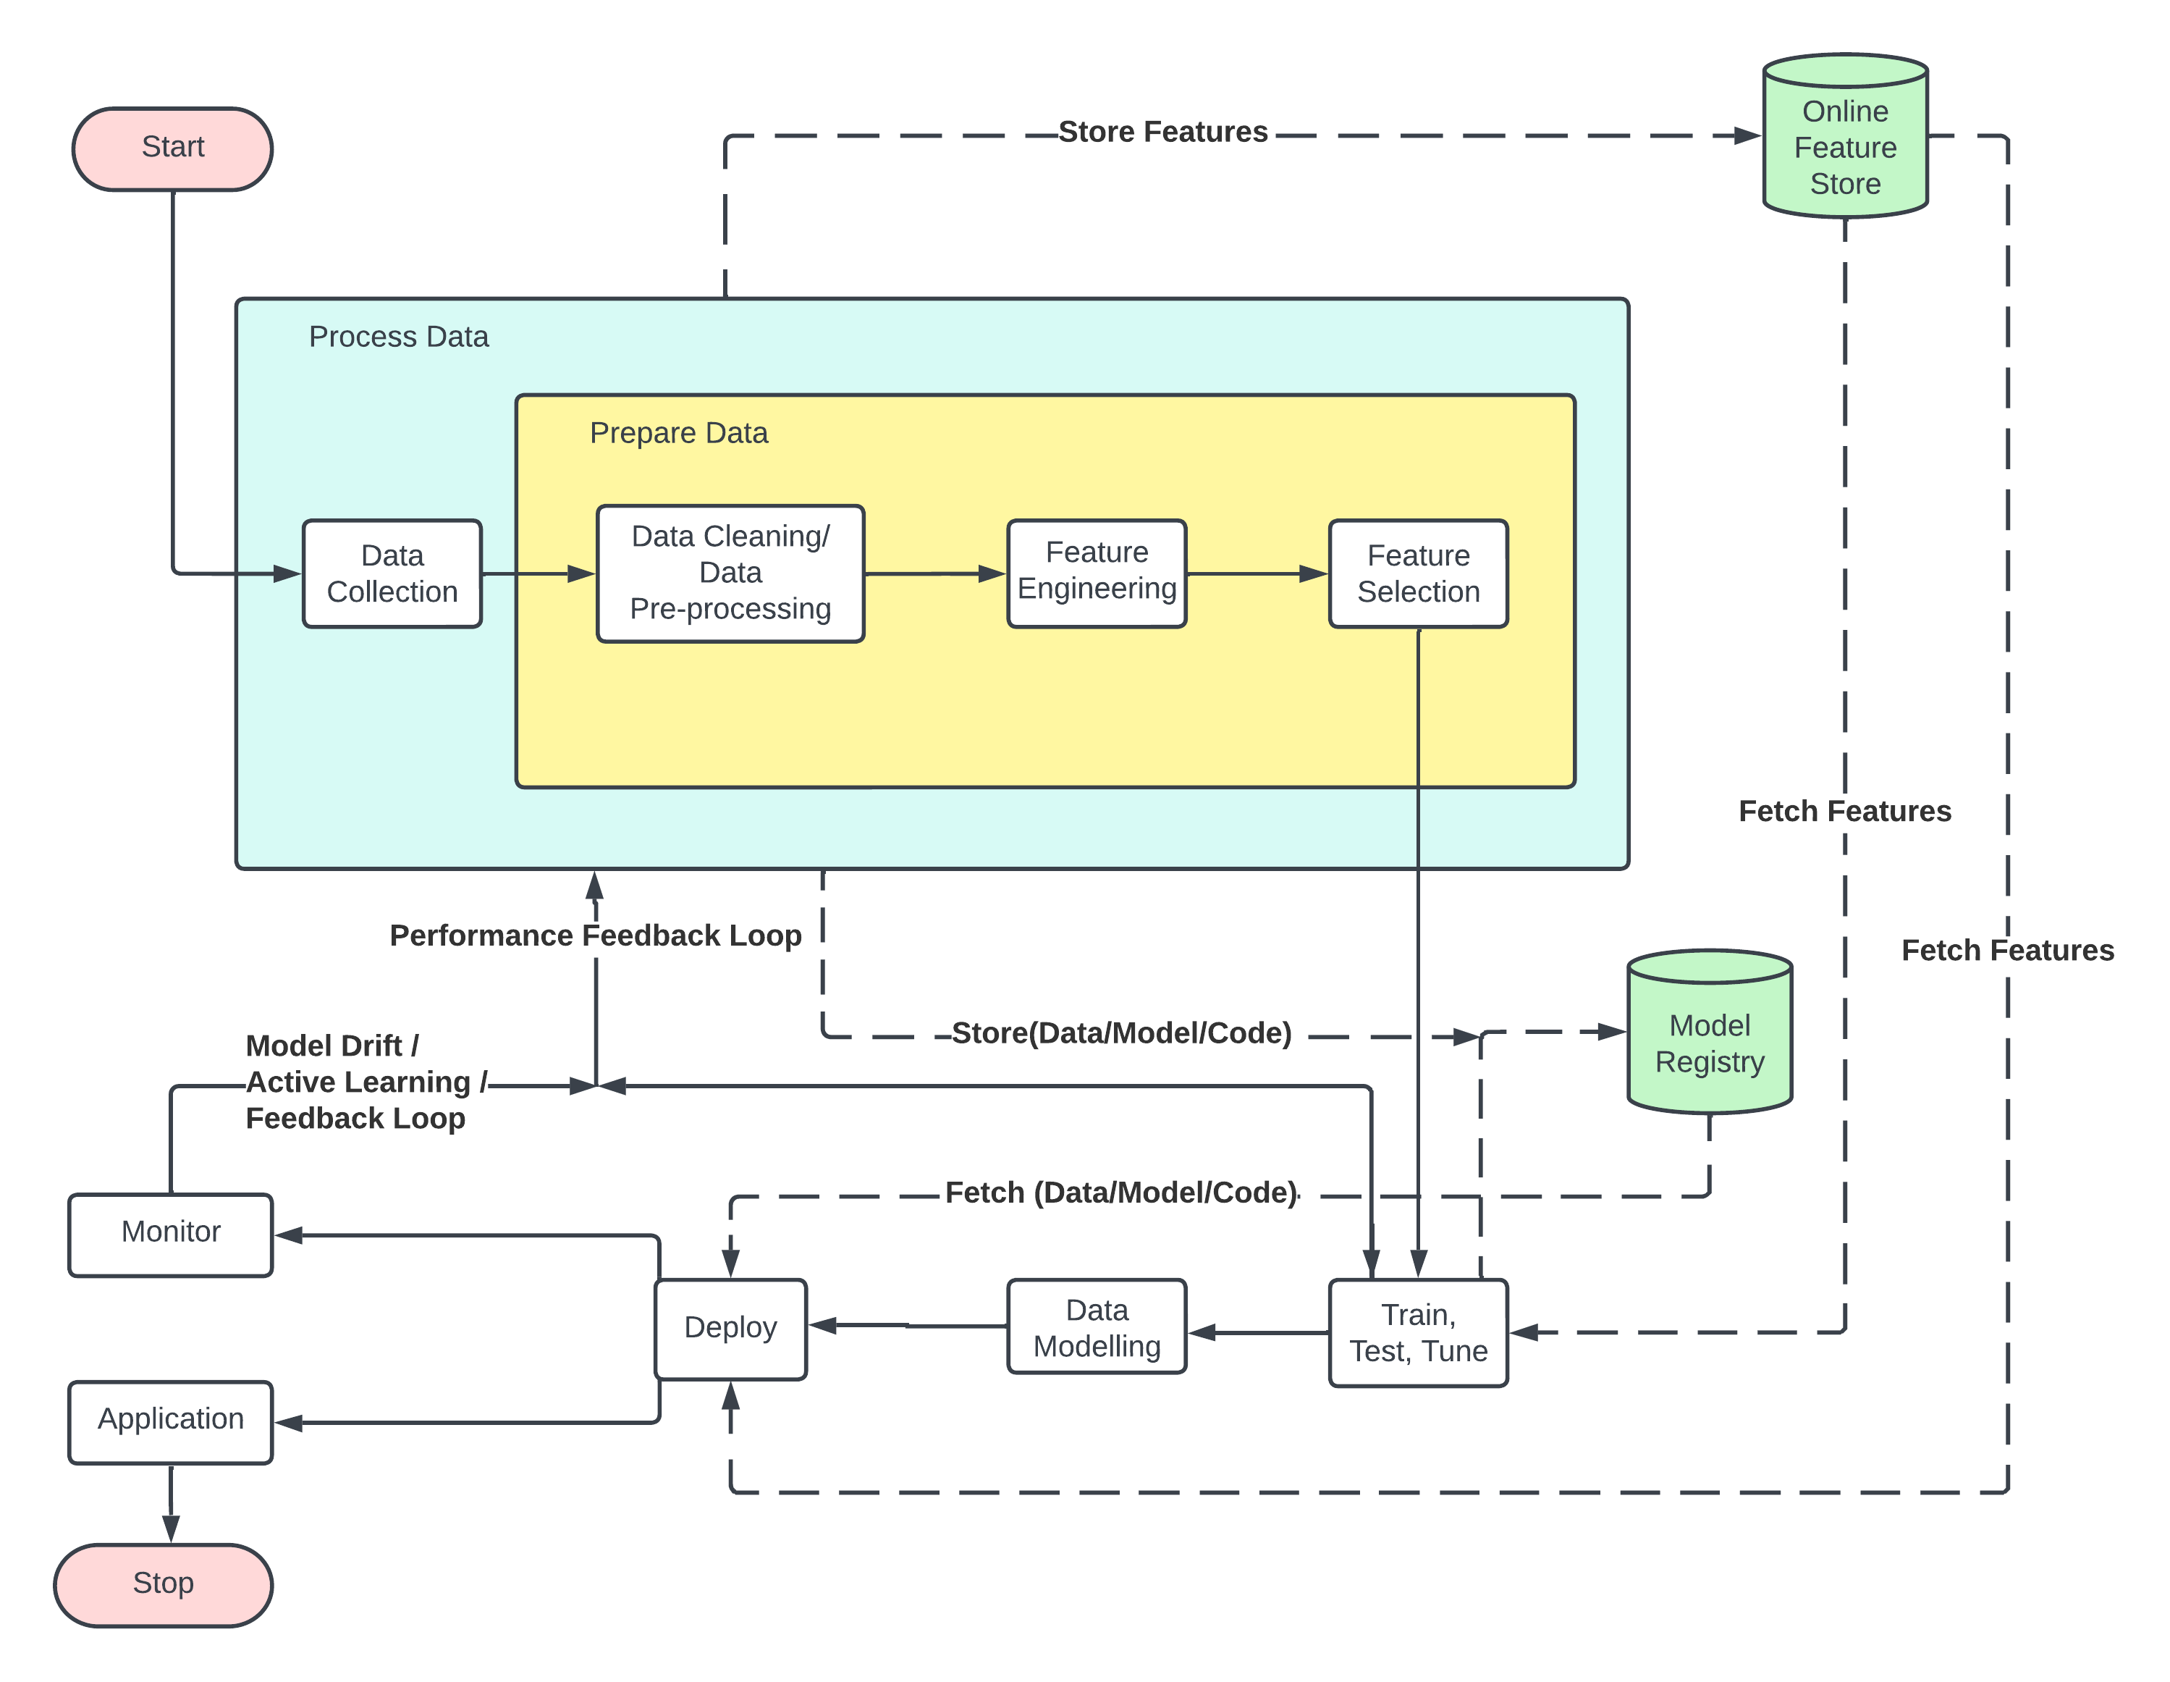

Figure 5.1: System Architecture for the Career Prediction Application

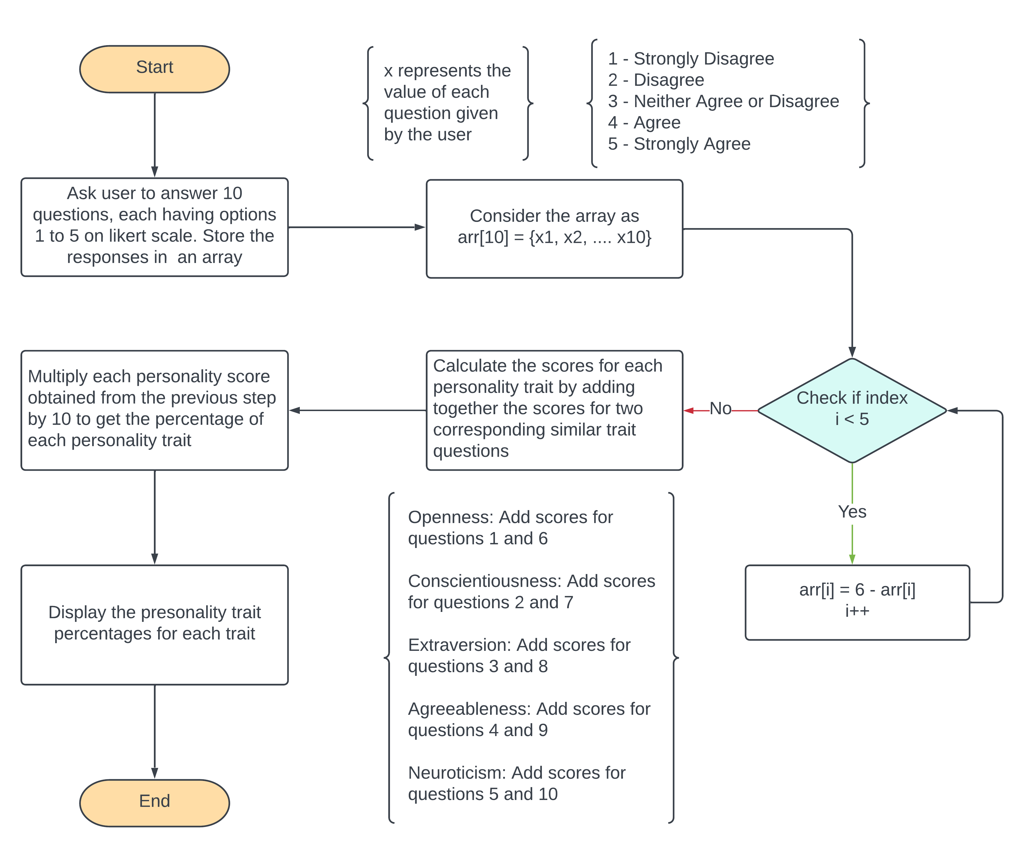

Figure 5.2: Flowchart of BFI-10 Scoring

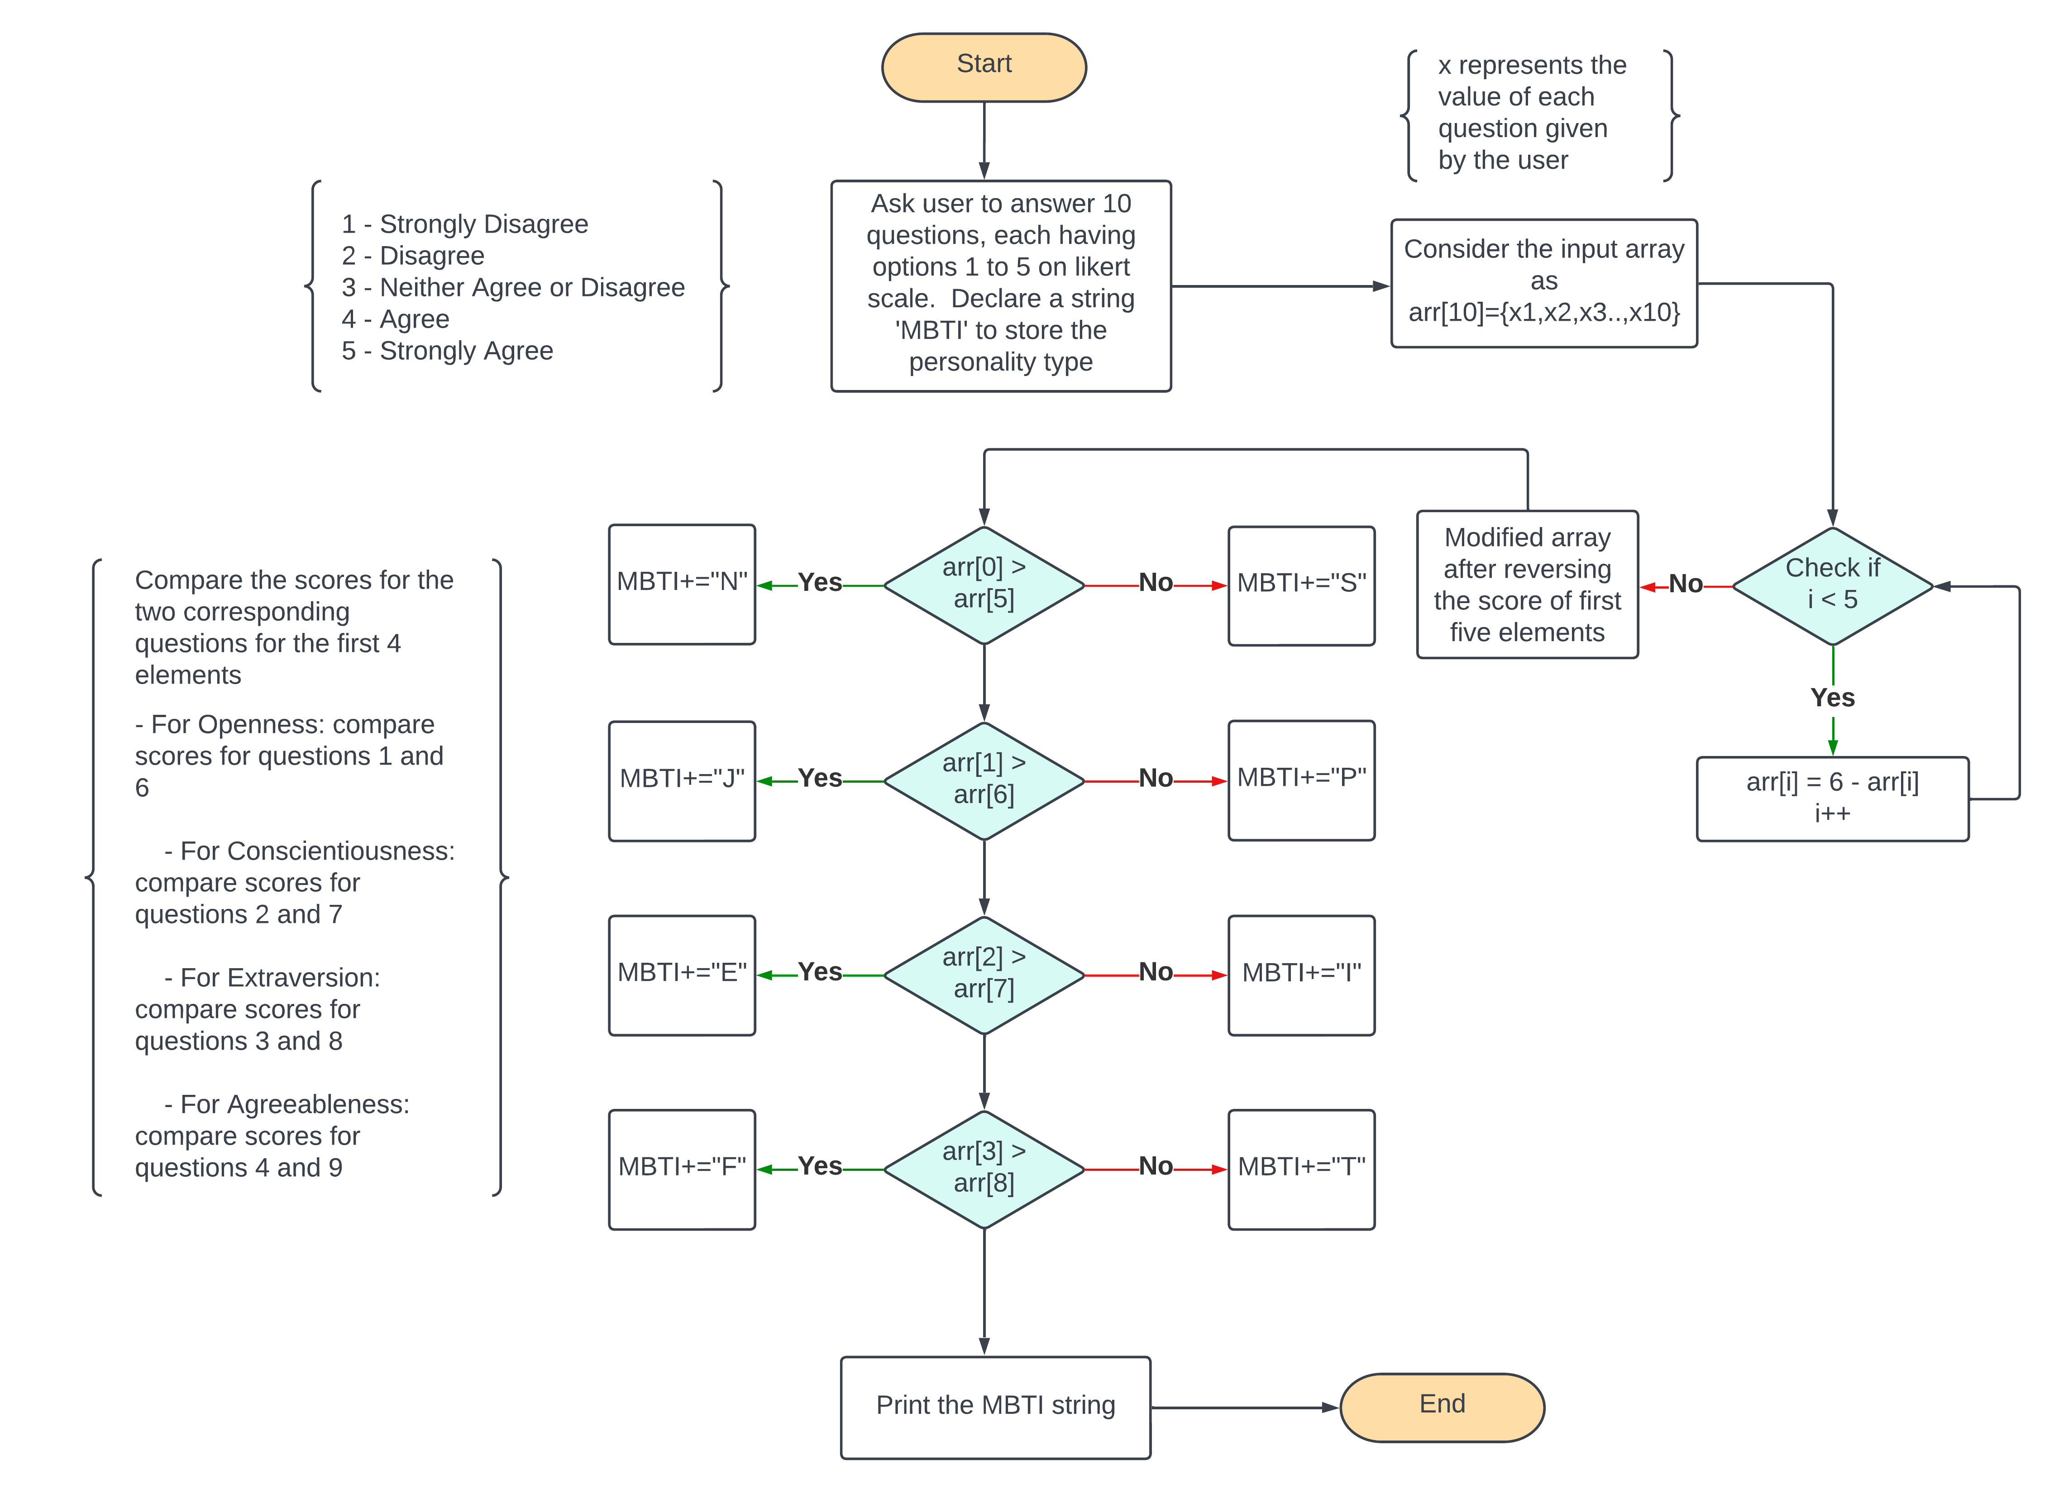

Figure 5.3: Flowchart of BFI-10 to MBTI Mapping

1. **IMPLIMENTATION DETAILS**

**6.1 Pseudo Code for BFI-10 Scoring:**

reverse_score(arr):

declare reverse_arr

copy arr into reverse_arr

iterate i from 1st to 5th index of arr

reversed_arr[i] <= 6 - arr[i]

return the reversed_arr

bfi_score(arr):

declare percentages array as empty array

iterate i from 1st to 5th index of arr

value <= arr[i] + arr[i+5]

value <= value * 10 //To convert to percentages

push value into percentages array

return the percentages array

**6.2 Pseudo Code for BFI-10 to MBTI Mapping:**

bfi10_to_mbti(arr):

declare mbti_type as empty arr

declare mbti as empty string

check if (OPN(R) > OPN) then append N to mbti (mbti += N)

else append S to mbti (mbti += S)

check if (CNS(R) > CNS) then mbti += J

else mbti += P

check if (EXT(R) > EXT) then mbti += E

else mbti += I

check if (AGR(R) > AGR) then mbti += F

else mbti += T

append mbti to multi_type

return the mbti_type string

**6.3 BFI Scoring:**

Consider the array arr = [4, 3, 2, 5, 5, 4, 1, 3, 1, 5]

This array “arr” represents the choices of selected by the user on a likert scale, where

1 represents “Strongly Disagree”

2 represents “Disagree”

3 represents “Neutral”

4 represents “Agree”

5 represents “Strongly Agree”

The questions displayed to the user arranged in such a manner that the first 5 questions are reverse scored, and remaining are normal scored. The 10 questions are arranged as

O(R) => C(R) => E(R) => A(R) => N(R) => O => C => E => A => N

(Trait wise ordered)

So, we need to change the scoring of first five elements, like this

for i in range 0 to 5,

arr[i] <= 6 - arr[i]

The rest of the scores remain unchanged.

Thus, the arr now becomes

arr = [(6-4), (6-3), (6-2), (6-5), (6-5), 4, 1, 3, 1, 5]

|  |  |  |  |  |  |  |  |  |  |  |
| --- | --- | --- | --- | --- | --- | --- | --- | --- | --- | --- |
| Index | 0 | 1 | 2 | 3 | 4 | 5 | 6 | 7 | 8 | 9 |
| Original Value | 4 | 3 | 2 | 5 | 5 | 4 | 1 | 3 | 1 | 5 |
| Modified Value | 2 | 3 | 4 | 1 | 1 | 4 | 1 | 3 | 1 | 5 |
| Traits | O | C | E | A | N | O | C | E | A | N |

Table 6.1: Table for BFI Scoring

Now, the modified array is used to find out the percentages of personality traits of Five Factor Model.

To find each personality trait, we take average of the traits normal and reverse scored values. In this case, to find openness trait percentage

To find out in percentage, we multiply “Openness” with 20

= 60

Do the same for all other traits.

Thus, finally the percentages of all 5 traits are,

|  |  |
| --- | --- |
| Personality Traits | Percentage Score |
| Openness | 60 |
| Conscientiousness | 40 |
| Extraversion | 70 |
| Agreeableness | 20 |
| Neuroticism | 60 |

Table 6.2: Table for Personality Trait Scores

**6.4 BFI-10 to MBTI Mapping:**

The Big Five Inventory (BFI-10) measures personality traits on five dimensions, whereas the Myers-Briggs Type Indicator (MBTI) categorizes personality types based on four dichotomies. Despite this fundamental difference, some researchers have attempted to map the BFI-10 onto the MBTI. Although there is ongoing debate about the relationship between the two models, some studies have suggested that openness is related to intuition, conscientiousness is related to judging, extraversion is related to extraversion, agreeableness is related to feeling, and neuroticism is related to introversion.

However, it's important to note that these mappings are not universally accepted. Some researchers argue that the MBTI is not a valid measure of personality and that the BFI-10 is a more accurate and reliable measure. Ultimately, the choice of which model or models to use depends on individual researchers' and practitioners' needs and preferences. Nevertheless, the BFI-10 remains a widely used tool for measuring personality traits and has been found to have strong psychometric properties, including high validity and reliability.

In conclusion, it can be stated that there is currently no formal or established mapping between the two models under consideration. The lack of a definitive relationship between the models suggests that further research and investigation may be necessary to explore any potential connections or correlations between them.

The paper "The Big Five Personality Dimensions and Job Performance: A Meta-Analysis" by Barrick and Mount published in 2002 identifies the following relationships between the Big Five personality traits and the Myers-Briggs Type Indicator (MBTI) personality traits:

* Openness is related to Intuition.
* Conscientiousness is related to Judging.
* Extraversion is related to Extraversion.
* Agreeableness is related to Feeling.
* Neuroticism does not relate to any MBTI trait.

In other words, individuals who score high on Openness are likely to prefer the Intuition function in MBTI, while those who score high on Conscientiousness tend to prefer the Judging function. Those who score high on Extraversion are likely to prefer Extraversion in MBTI, and those who score high on Agreeableness are likely to prefer Feeling. However, Neuroticism does not show a significant relationship with any of the MBTI traits.

So, the mapping function is

if (OPN(R) > OPN) mbti += N

else mbti += S

if (CNS(R) > CNS) mbti += J

else mbti += P

if (EXT(R) > EXT) mbti += E

else mbti += I

if (AGR(R) > AGR) mbti += F

else mbti += T

Consider the array from the previous example,

arr = [4, 3, 2, 5, 5, 4, 1, 3, 1, 5]

After the reverse scoring,

|  |  |  |  |  |  |  |  |  |  |  |
| --- | --- | --- | --- | --- | --- | --- | --- | --- | --- | --- |
| Index | 0 | 1 | 2 | 3 | 4 | 5 | 6 | 7 | 8 | 9 |
| Original Value | 4 | 3 | 2 | 5 | 5 | 4 | 1 | 3 | 1 | 5 |
| Modified Value | 2 | 3 | 4 | 1 | 1 | 4 | 1 | 3 | 1 | 5 |
| Traits | O | C | E | A | N | O | C | E | A | N |

Table 6.3: Table for BFI to MBTI mapping

**(Openness)**

if (arr[0] > arr[5]) mbti = N

else mbti = S

if (2 > 4) mbti = N

else mbti = S

Thus, we get mbti = S

Similarly, do the above calculation for all traits except Neuroticism.

Thus, the final MBTI traits are:

(Openness)

arr[0] > arr[5]

* 2 > 4, so mbti = S

(Conscientiousness)

arr[1] > arr[6]

* 3 > 1, so mbti = J

(Extraversion)

arr[2] > arr[7]

* 4 > 3, so mbti = E

(Agreeableness)

arr[3] > arr[8]

* 1 > 1, so mbti = T

So, the corresponding MBTI personality type for the given input array becomes

**“ESTJ”**

1. **RESULTS AND DISCUSSIONS**

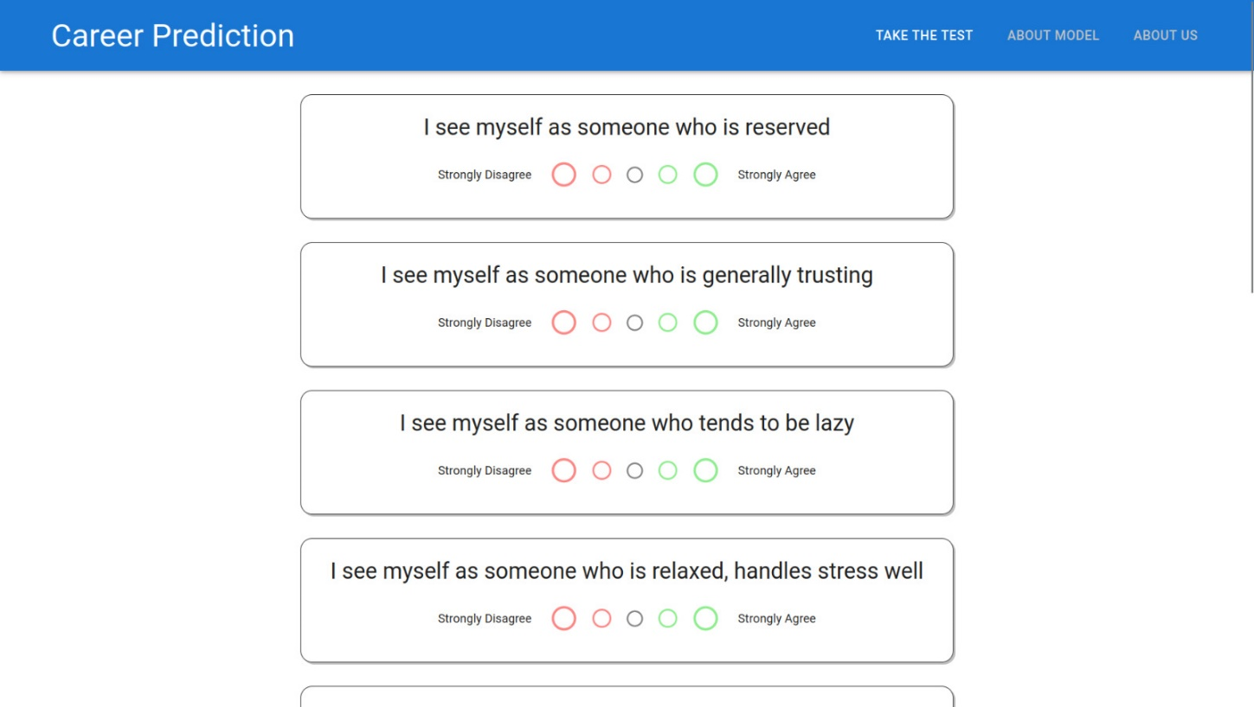

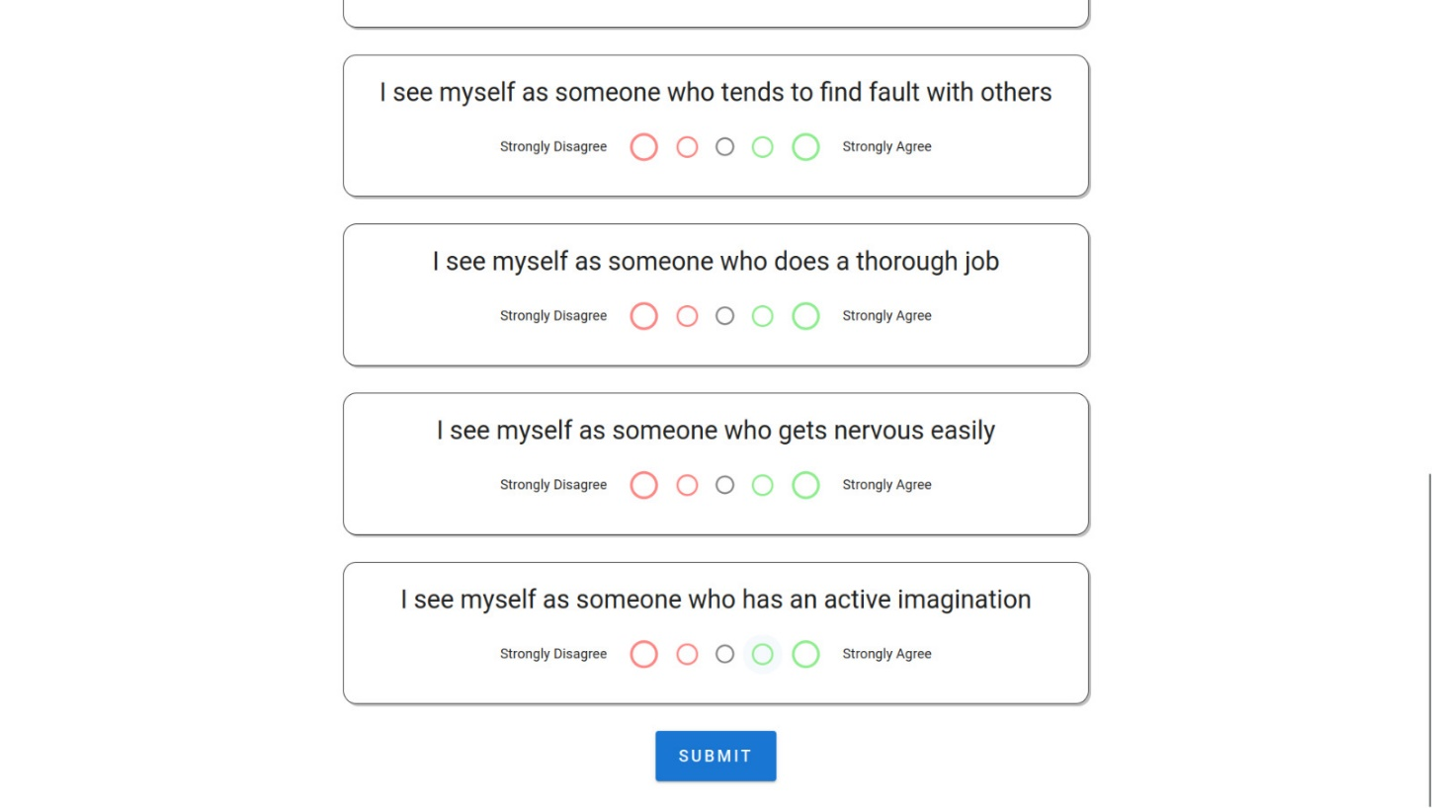

Figure 7.1: Home Page

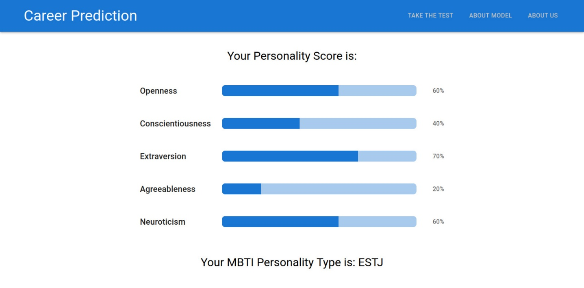

Figure 7.2: Results Page

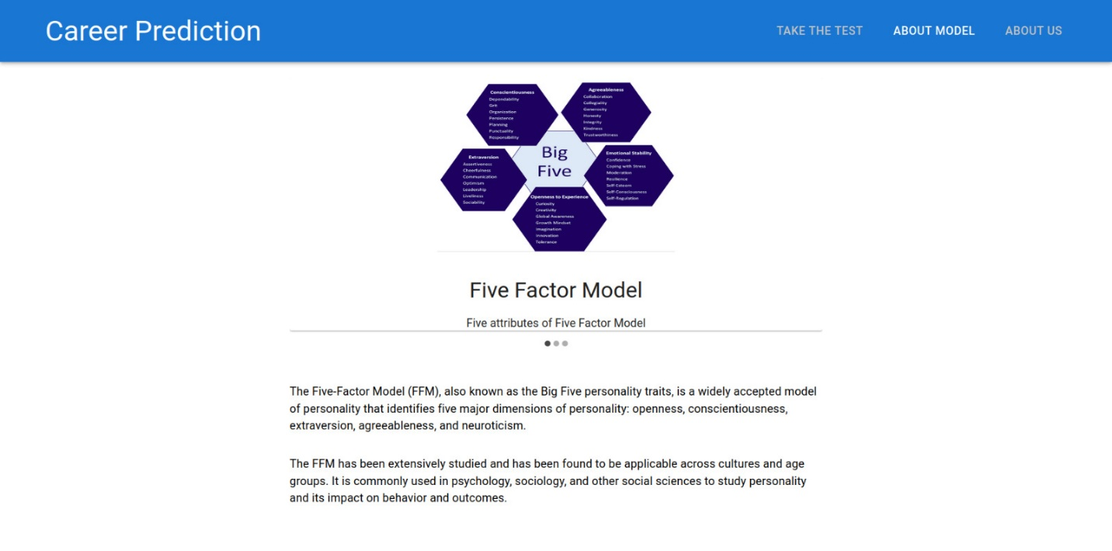

Figure 7.3: About Model Page

1. **CONCLUSION**

The research report examined various personality models, including the Five Factor Model (FFM), the Myers-Briggs Type Indicator (MBTI), and Holland's model and the Big Five Personality Model (BFI) was found to be the most suitable for personality prediction. However, a drawback of the BFI model is the absence of standardized career mapping. On the other hand, the Myers-Briggs Type Indicator (MBTI) model has a standardized mapping of careers, but its reliability is debated among researchers.

As per our findings, we chose to use the BFI model for personality prediction and the MBTI model for personality to career mapping. We established a mapping function between BFI and MBTI personality traits, allowing the use of MBTI's existing personality to career mapping to predict career options.

Our research emphasizes the importance of selecting an appropriate personality model for specific research objectives. In addition, we used the BFI-10 questionnaire in our data collection process, providing a quick and efficient assessment of the Big Five personality traits.

1. **LIMITATIONS & FUTURE SCOPE OF THE PROJECT**

**9.1 Limitations of the Project:**

The FFM, despite being widely used and considered the most suitable model for personality prediction, does not have a standardized career mapping from its five personality traits. This makes it difficult to directly apply the model's personality assessment to career prediction without additional steps or mapping functions.

On the other hand, the MBTI model has a standardized career mapping from its 16 personality types, but its reliability is widely debated among researchers. Critics argue that the model lacks empirical evidence to support its theoretical assumptions and that its personality types are oversimplified and do not capture the complexity of individuals' personalities.

The current solution being utilized for career prediction does not provide validated career outcomes due to the absence of a standardized mapping between the two personality indicators being utilized. As a result, the reliability of the outcomes generated from this approach is not promoted. In other words, the lack of a standardized mapping function between the personality indicators being used in this research project undermines the credibility and accuracy of the career predictions being made. Without a reliable and validated approach, the outcomes generated from this solution cannot be trusted for decision-making purposes.  
  
In addition to the above limitations, our BFI to MBTI mapping function does not include the Neuroticism trait. This means that the mapping function does not fully capture the nuances of individuals' personalities and may not provide a complete picture of their career preferences. Neuroticism is an important trait that affects individuals' emotional stability and anxiety levels, and it has been shown to influence career choices. Therefore, not including it in the mapping function may limit the accuracy and reliability of the career predictions being made. Further research is needed to explore the relationship between Neuroticism and career outcomes and to develop a more comprehensive mapping function that includes this trait.

**9.2 Future Scope of the Project:**

After identifying the limitations of the research project, the areas that require improvement have been recognized, and they are as follows:

**Develop a standardized career mapping for the FFM model:** The lack of a standardized career mapping for the FFM model makes it difficult to apply the model's personality assessment to career prediction. Future research can focus on developing a standardized career mapping for the FFM model that can provide reliable and validated career outcomes.

**Conduct further validation of the MBTI model:** Despite its popularity, the reliability of the MBTI model is debated among researchers. Future research can focus on conducting further validation studies of the MBTI model to assess its validity and reliability in predicting career outcomes.

**Explore the relationship between Neuroticism and career outcomes:** The exclusion of the Neuroticism trait from the mapping function may limit the accuracy and reliability of the career predictions being made. Future research can explore the relationship between Neuroticism and career outcomes to develop a more comprehensive mapping function that includes this trait.

The potential for further development and implementation of this career prediction system is vast, offering ample opportunities for future research and application across various industries.

1. **GANTT CHART**

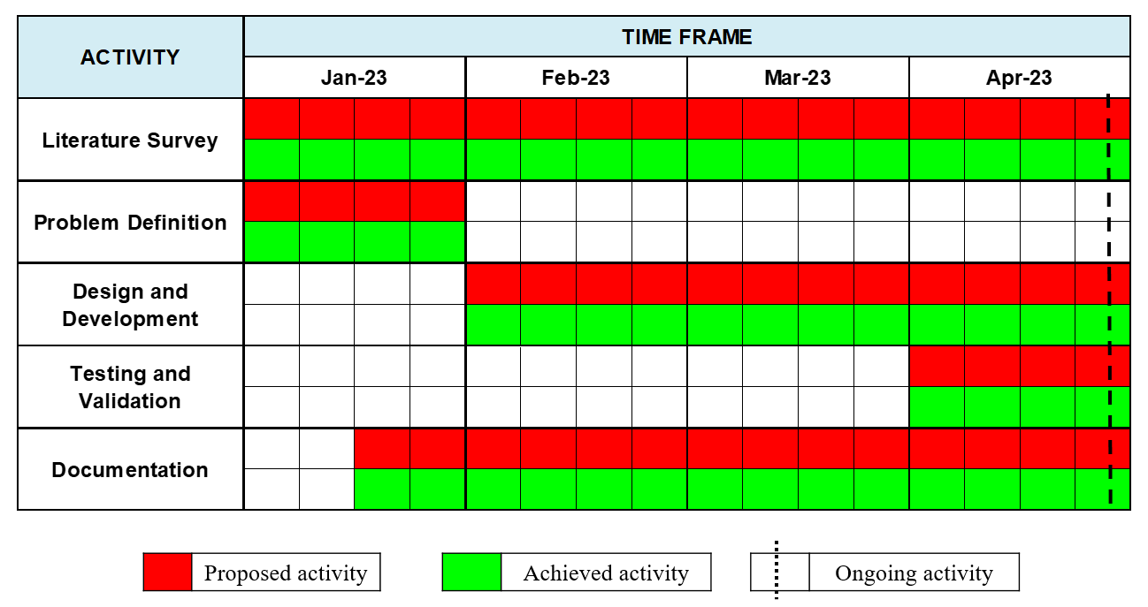

Figure 10.1: Gantt chart

1. **REFERENCES**

[1] Rammstedt, B. & John, O.P. Measuring personality in one minute or less: A 10-item short version of the Big Five Inventory in English and German [2007]

[2] Pratiyush Guleria, Manu Sood. Explainable AI and machine learning: performance evaluation and explainability of classifiers on educational data mining inspired career counselling [2022]

[3] Prof. Priyanka Shahane, Prutha Rinke, Taniksha Datar, Soham Badjate. Student’s Career Interest Prediction using Machine Learning [2022]

[4] Chelsea Song, Hyun Joo Shin, Chen Tang, Alexis Hanna, et. al. Investigating machine learning’s capacity to enhance the prediction of career choices [2022]

[5] Abhishek S Rao, Bola Sunil Kamath, Ramya R, Shreya Chowdhury, et. al. Neural network in developing a personality prediction model for career guidance: A Boon for Career [2021]

[6] Murray R. Barrick, Michael K. Mount. The Big Five Personality Dimensions and Job Performance: A Meta-Analysis [2002]

[7] Why are they called Big 5 and not Fabulous 4? (n.d.). Schuhfried. <https://www.schuhfried.com/en-blog/big-5/>

[8] Warner Jon. (2012, November 30). Is Type and Temperament the Same? ReadyToManage. <https://blog.readytomanage.com/is-type-and-temperament-the-same/> [2012]